Write a hive UDAF to find the largest integer in a column. Use your own dataset for the above problem statement and attach the steps performed, codes used with the result.

UDF:

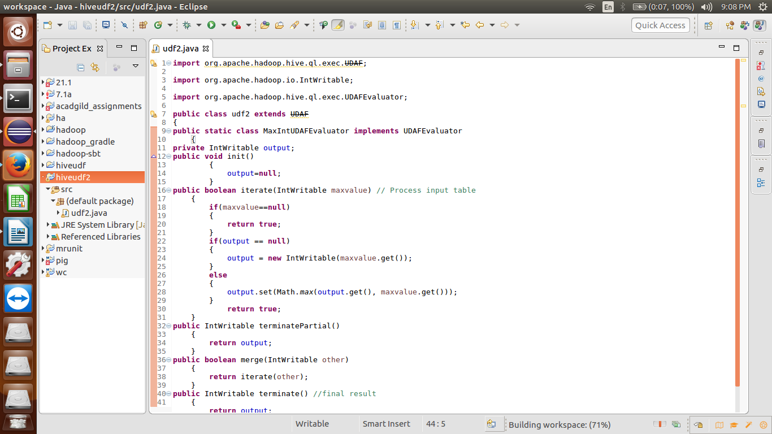

Adding the jar file:

Creating a temporary function:

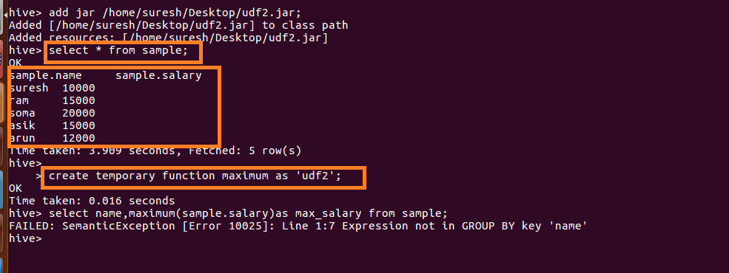

Getting the maximum salary: